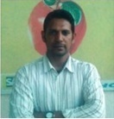

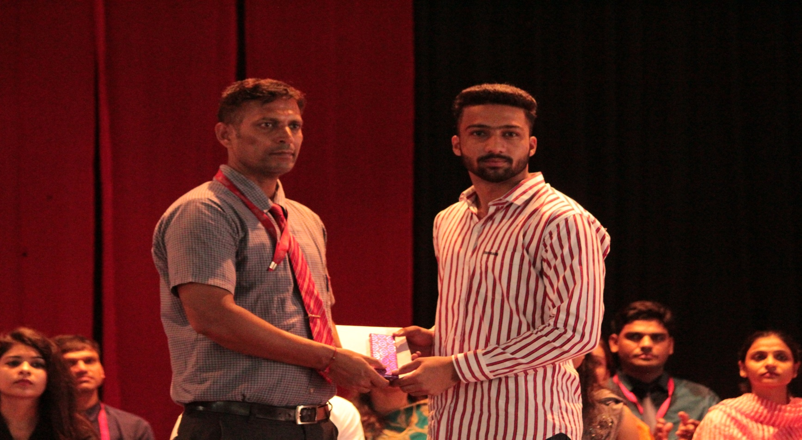
SATISH KUMAR YADAV
HOD( Physical education & Sports)
House master (vidushree house)
BRCM PUBLIC SCHOOL
VIDYAGRAM , BAHAL
Mob. +918447507377

Career Objective

Intend to have a career, which would exploit my potentials to its maximum and evolve me as a better professional throughout my career.

Work Experience

Presently working with BRCM Public School, Bahal,Haryana, (Fully Residencial IPSC school,member of British Council, INTACH ,SPIC MACAY ,IAYP and NCC) as a HOD (PE & SPORTS) & House master from March 2017 to till date.

- Taught Physical education subject to 11th & 12th classes.
- Work as cricket & yoga coach.
- Head of sports department.
- Overall responsibility of discipline.
- Instructor of Aerobics, power yoga and Gym.
- Regular visit to hostel for better interaction with the students
- To solve the day to day problems of the students
- To deal with the acts of indiscipline of the students
.Worked with JRE Group Of Institutions( joint venture of raffles group singapur & Educomp group India), Greater Noida as Sports officer cum Hostel warden from Aug. 2012 to March 2017

• Instructor of Badminton, Cricket,Yoga and Aerobics
• In-charge of Fitness & Wellness program

• Head of Sports & Hostel department.
• Member of Disciplinary Committee.

Worked in Happy Public School Alwar (CBSE ) as PGT (physical education) from July 2005 to July 2012.

- Instructor of Badminton, Cricket, Volleyball and Athletics.

- Taught Physical Education subject to senior classes.
- Head of School Discipline Committee

Professional Qualifications

- Certificate course in yoga science (2019)
- MBA in Education Management (2014-2016).
- PG Diploma in Sports Management (2012-13).
- Master in Physical Education(2000-2002)
- Bachelor in Physical Education (1999-2000)

Educational Qualifications:

- Bachelor of Arts(1996-1999) from Rajasthan University, Jaipur

- Sr.Sec. (1996) from Rajasthan Board, Ajmer
- Sec. (1994) from Rajasthan Board, Ajmer

Sports Performances

1996-Participated in State School Cricket Championship, Udaipur, Rajasthan

2000-Participated in Junior National Athletic Meet, Cuttack, Orissa

2000-Participated in All India University Cross Country Championship, kottayam, Kerala

2000- Participated in All India University Athletic Meet, Gwalior, and M.P.

2001-Participated in All India University Cross Country Championship, Jargon, Goa

2001-Participated in All India University Athletic Meet, Amritsar, Punjab

2002-Participated in All India University Athletic Meet, Kottayam, Kerala

2003-Officiated in Six-A-Side National Cricket Championship, Ahmdabad,Gujarat

2012-Organizing Secretary of JRE Sports Meet CANVAS.

2018-Organising secretary of IPSC Volleyball Championship at BRCM Bahal

2019- Organising secretary of IPSC Volleyball Championship at BRCM Bahal

2019-Organising secretary of IPSC Table Tennis championship at BRCM Bahal .

Personal Details

Name | Satish Kumar Yadav
Address | Plot no.-290, Block-C, Raath Nagar, Alwar, Rajasthan
Contact Number | +918447507377
Email Id | satishalwar29@gmail.com
Date of Birth | 29th Sep. 1979
Marital Status | Married
Nationality | Indian

References:

Prof. Hari P. Sharma Prof. Chattar Singh Mr Mukul Bhandari
HoD,( Management) Dean EX Principal
Virginia State University RNB Global University BRCM Public School
USA Bikaner, Rajasthan Bahal (Haryana)

E: professorsharmahari@gmail.com mob. 9355166134 mob no-9992900381
M: 804-712-1300

Place: Bahal,Bhiwani (Satish Kumar Yadav)

